Cadence login instructions

You will need to be on the VPN to access the server or, you can access it from the lab PCs or via a VM.

The hostname for the Server is **capc-cadence.msucap.com** (172.20.3.173)

You can use Putty or some other program to SSH into it. You have to enable X11 forwarding

Note: (I believe Linux should have a built-in X-server. You can use an application called Xming if you are using Windows ([Xming X Server for Windows download | SourceForge.net](https://sourceforge.net/projects/xming/)) and XQuartz for Mac ([XQuartz](https://www.xquartz.org/)))

**For Windows**

Below is a sample Putty configuration with X11 forwarding enabled and the location of the X authority file (Xming.exe). **“You can also leave the X authority file for local display” blank**

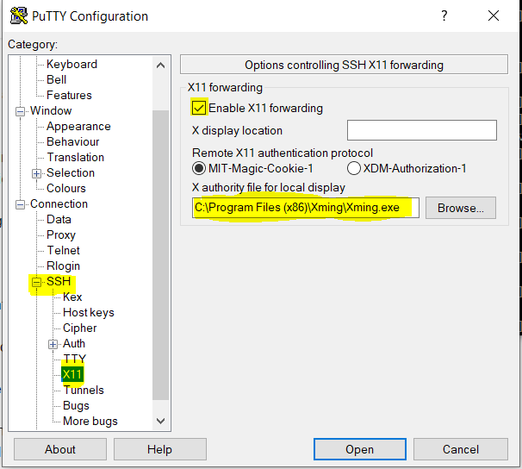

You can use your CAP Center credentials to log into the server (username and password)

**For MAC OS**

Open a terminal on your Mac (this can be done by going to Launchpad)

Type **ssh -X <userName>@172.20.3.173** (for example: ssh -X vi.morris@172.20.3.173)

Input your password

Note: Some applications may require -Y instead of -X

1. Once you log in, you can create a directory (i.e. cadence)

***mkdir cadence***

2. copy the following cshrc file to your home directory

**cp /usr/local/cadence/files/.cshrc ~/**

3. change to the directory that you created (ie cadence)

**cd cadence** (or whatever you called the directory)

4. change the shell to csh

***csh***

5. Issue the command

**source ~/.cshrc**

6. launch the application virtuoso

**virtuoso &**

This should launch the virtuoso application in a GUI

**Alternate Method**

Alternatively you can use VNC instead of an X-server

You will need to install a VNC viewer (RealVNC is a good one to use)

To use VNC you will need to log into the server via SSH and setup a VNC password

Issue the following command in the terminal

**vncpasswd**

type the password that you want

confirm the password

select **no** for read only password

Once you have done this let me know, and I will enable the service and set it to automatically start

Once the service is running launch the VNC application on your PC

Enter **172.20.3.173:#** in the VNC server address (# is unique to each user)

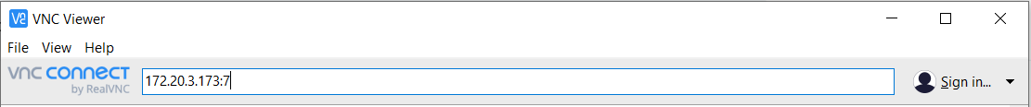

Log in with the VNC Password that was set

You may be required to log in with your CAP credentials

Once you log in, you can launch a terminal and begin with step 1 above

If you run into any issues, please let me know.